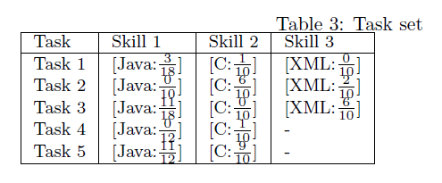

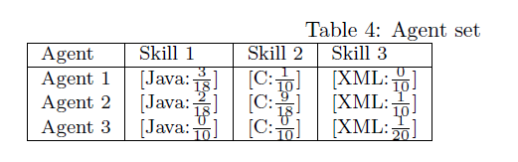

|  |  |  |  |  |
| --- | --- | --- | --- | --- |
| 12 | 49.0 | heterophyly | choice | none |
| 13 | 50.0 | heterophyly | choice | none |
| 17 | 51.0 | heterophyly | choice | none |
| 22 | 52.0 | heterophyly | proportional | none |
| 31 | 53.0 | heterophyly | greedy | none |
| 40 | 54.0 | heterophyly | random | none |
| 18 | 51.0 | heterophyly_experience | choice | none |
| 19 | 51.0 | heterophyly_experience | proportional | none |
| 23 | 52.0 | heterophyly_experience | choice | none |
| 24 | 52.0 | heterophyly_experience | proportional | none |
| 32 | 53.0 | heterophyly_experience | greedy | none |
| 14 | 50.0 | homophyly | choice | none |
| 25 | 52.0 | homophyly | greedy | none |
| 26 | 52.0 | homophyly | proportional | none |
| 27 | 52.0 | homophyly | random | none |
| 33 | 53.0 | homophyly | greedy | none |
| 34 | 53.0 | homophyly | random | none |
| 15 | 50.0 | homophyly_experience | choice | none |
| 28 | 52.0 | homophyly_experience | proportional | none |
| 35 | 53.0 | homophyly_experience | greedy | none |
| 36 | 53.0 | homophyly_experience | random | none |
| 41 | 54.0 | homophyly_experience | greedy | none |
| 42 | 54.0 | homophyly_experience | random | none |
| 16 | 50.0 | preferential | choice | none |
| 20 | 51.0 | preferential | choice | none |
| 21 | 51.0 | preferential | proportional | none |
| 29 | 52.0 | preferential | greedy | none |
| 37 | 53.0 | preferential | greedy | none |

0. First time run (circa 3 times an getting rid of errors)

a) without evolution model

1. Integrate to CSV dump and Gephi visualization!

2. First time run (circa 10 times)

a) 100 agents

b) all strategies separately

c) choosing best and worst strategies

3. More runs

a) mixing best-best strategies

b) mixing best-medium strategies

4. Implementing evolutionary model

Parameterization

experienceDecay

fullyLearnedAgentsLeave

experienceSigmaPoint

339/12/2013 11:46: sigmoid(-3.000): 0.04742587317756679

339/12/2013 11:46: sigmoid(0.000): 0.5

339/12/2013 11:46: sigmoid(0.005): 0.5012499973958399

339/12/2013 11:46: sigmoid(0.505): 0.623633628298226

339/12/2013 11:46: sigmoid(0.995): 0.7300743839811188

339/12/2013 11:46: sigmoid(1.000): 0.7310585786300049

339/12/2013 11:46: sigmoid(3.000): 0.9525741268224331